Offshore Essentials
Open-water trawler travel
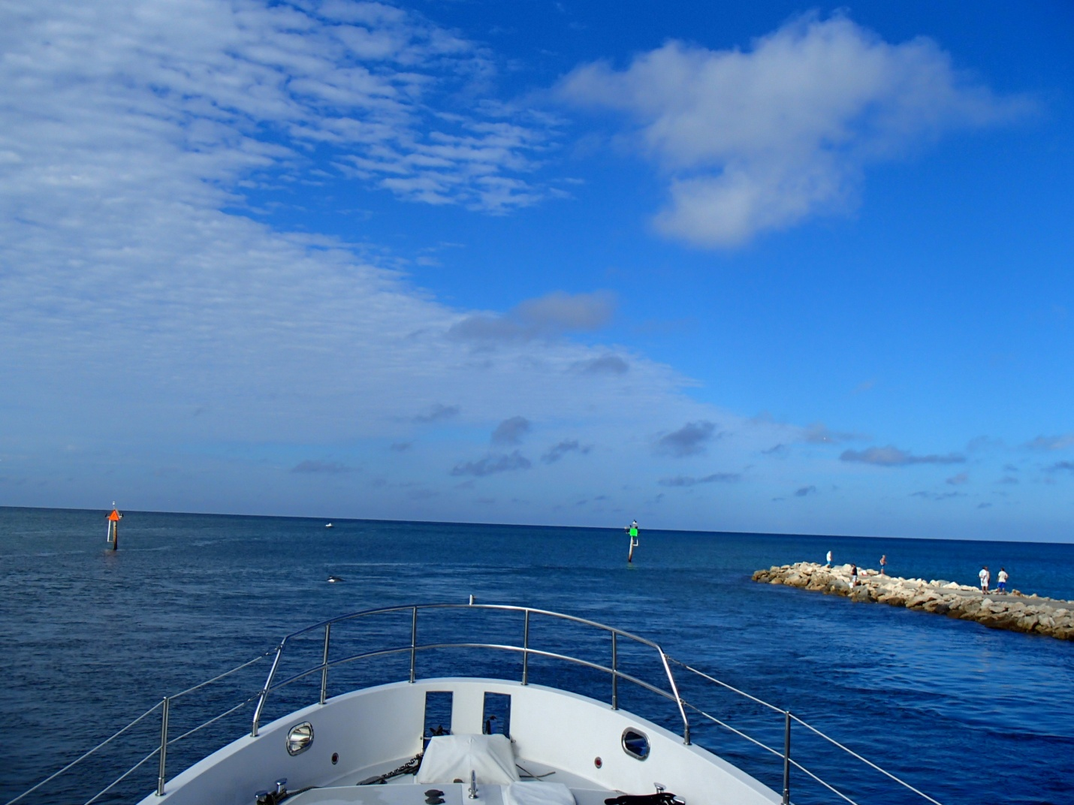
TrawlerFest | PassageMaker Magazine
Seattle, WA April 26th, 2019
By Jeff Merrill © 2019 all rights reserved www.JMYS.com

