Offshore Essentials
Open-water trawler travel
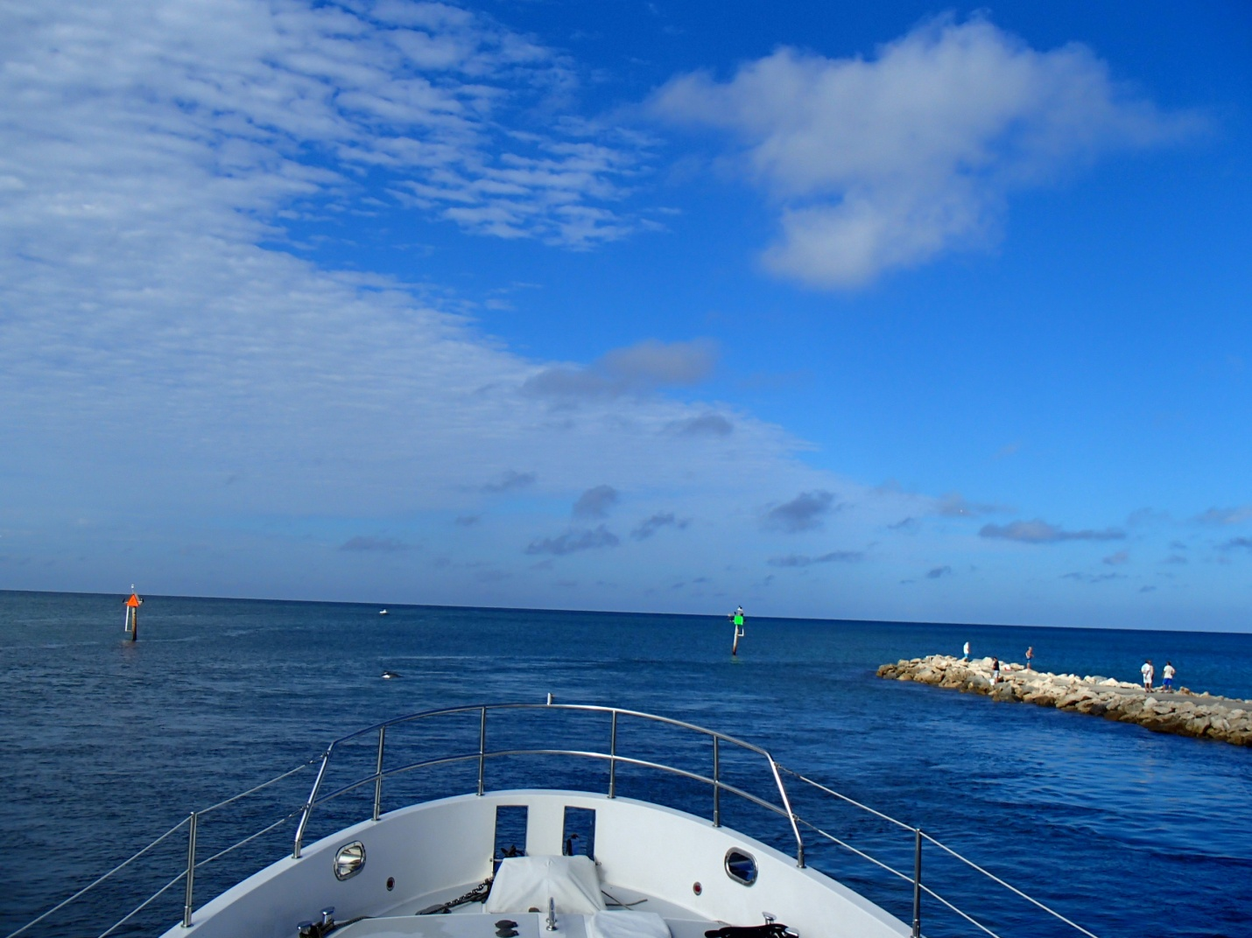
TrawlerFest | PassageMaker Magazine
Zoom LIVE November 13, 2020
By Jeff Merrill © 2020 all rights reserved www.JMYS.com

