Heading Offshore 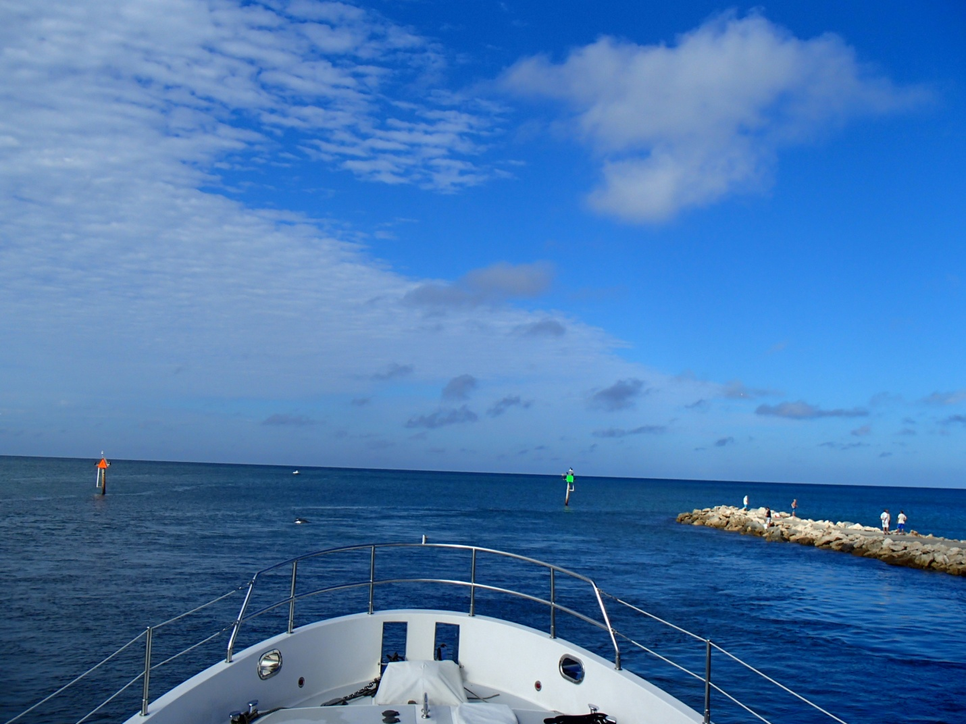
TrawlerFest | PassageMaker Magazine
Stuart, FL
By Jeff Merrill © 2023 all rights reserved www.JMYS.com

