Heading Offshore 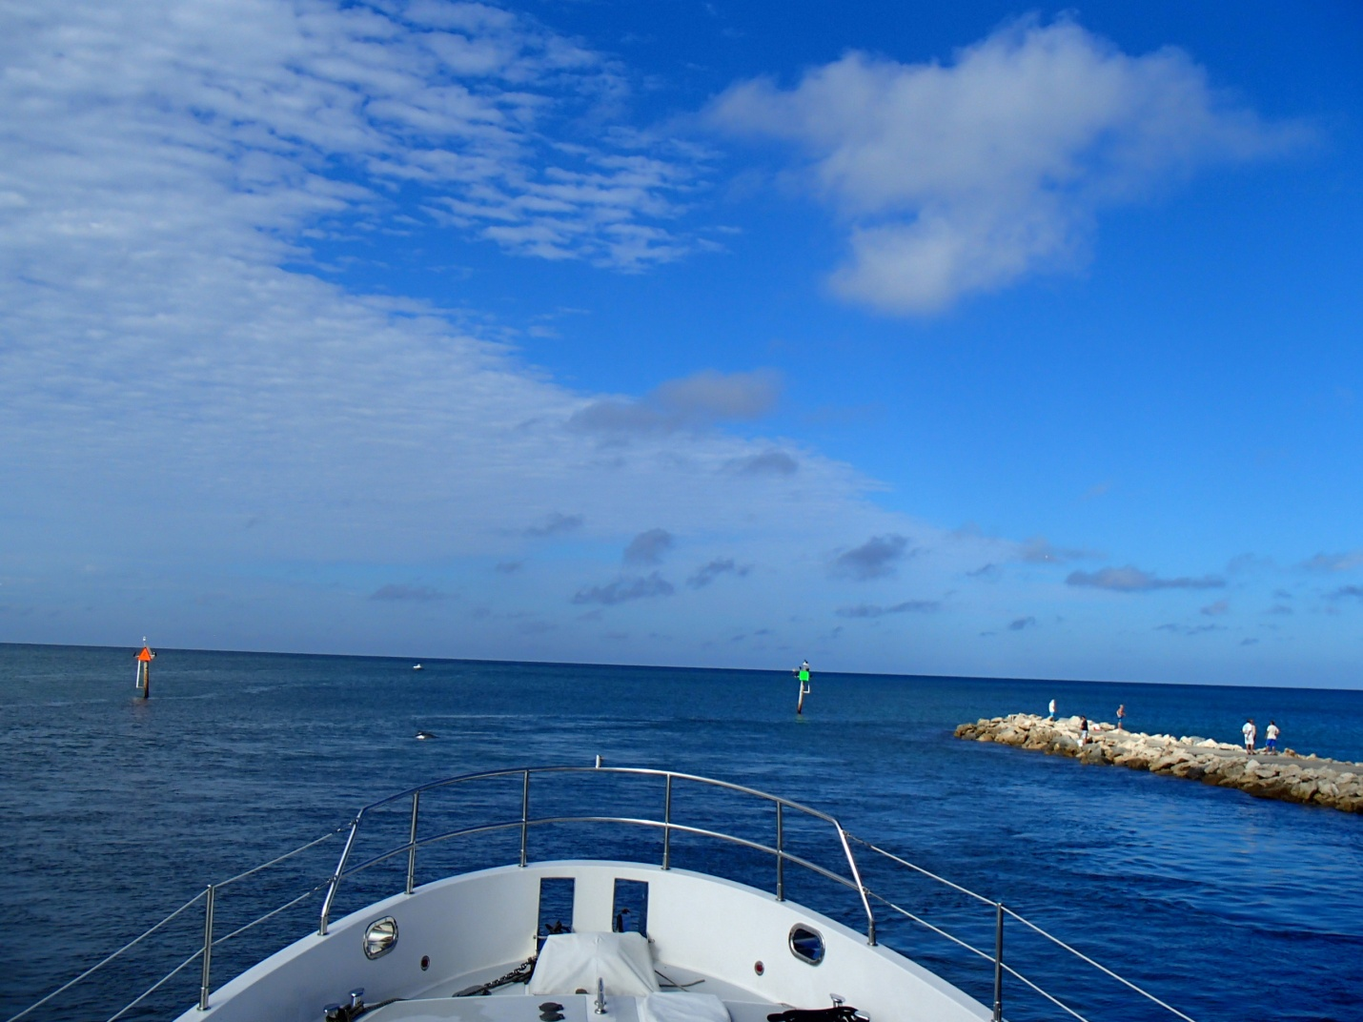
TrawlerFest | PassageMaker Magazine
Anacortes, WA
By Jeff Merrill © 2024 all rights reserved www.JMYS.com

