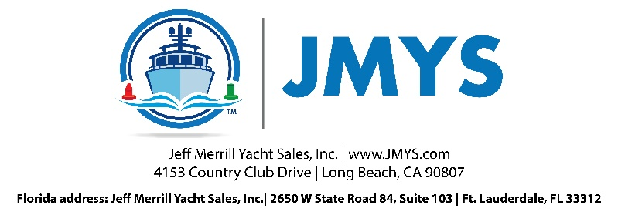

US Coast Guard Requirements
EXAMPLE: Nordhavn 5017 Northern Ranger II

Minimum Coast Guard Safety requirements (and locations)
6 Ea. Type II life jackets - dock box on boat deck
1 Ea. Bernard Oil Discharge placard – ER door on inside
1 Ea. Bernard Waste Discharge placard – under galley sink locker door
1 Ea. Safety blaster – pilothouse – starboard locker door under dash
1 Ea. Chrome bell– pilothouse inside (starboard side)
1 Ea. Jim Buoy Life ring – (cockpit)
1 Ea. Flare kit– pilothouse wet hanging locker
5 Ea. Fire extinguishers – (three required)
- Saloon aft locker by door
- Saloon stairs to pilothouse (outboard).
- Pilothouse – forward stair locker – starboard
- Master head - forward
e) Engine room – just inside forward door to port
f) Boat Deck – inside dinghy

Owner should have a waste management/trash plan in place (ships papers)
US Coast Guard Rules of the road book – white one – (pilot house book shelf)
Through hulls closed for holding tank discharge and toilets?
Note: Are Y-valves set to go to overboard or to holding tank?
Holding tank through hull in locker forward (behind) master head – should be closed.
Forward head through hull under sink – closed?
Aft head through hull under MSR- closed?
note: HIN – hull identification number – on starboard transom and hidden in lazarette
note: USCG number –above lazarette/engine room door in lazarette

Extras:
Fire suppression – Engine room and Lazarette (both pulls in MSR aft port side hanging locker
Fire blanket – galley pantry locker
Ditch bag – pilothouse wet locker
Lifesling – cockpit under stairs

© 2024 JMYS www.JMYS.com PAGE 4

