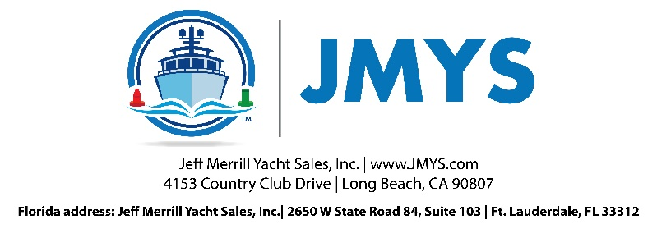

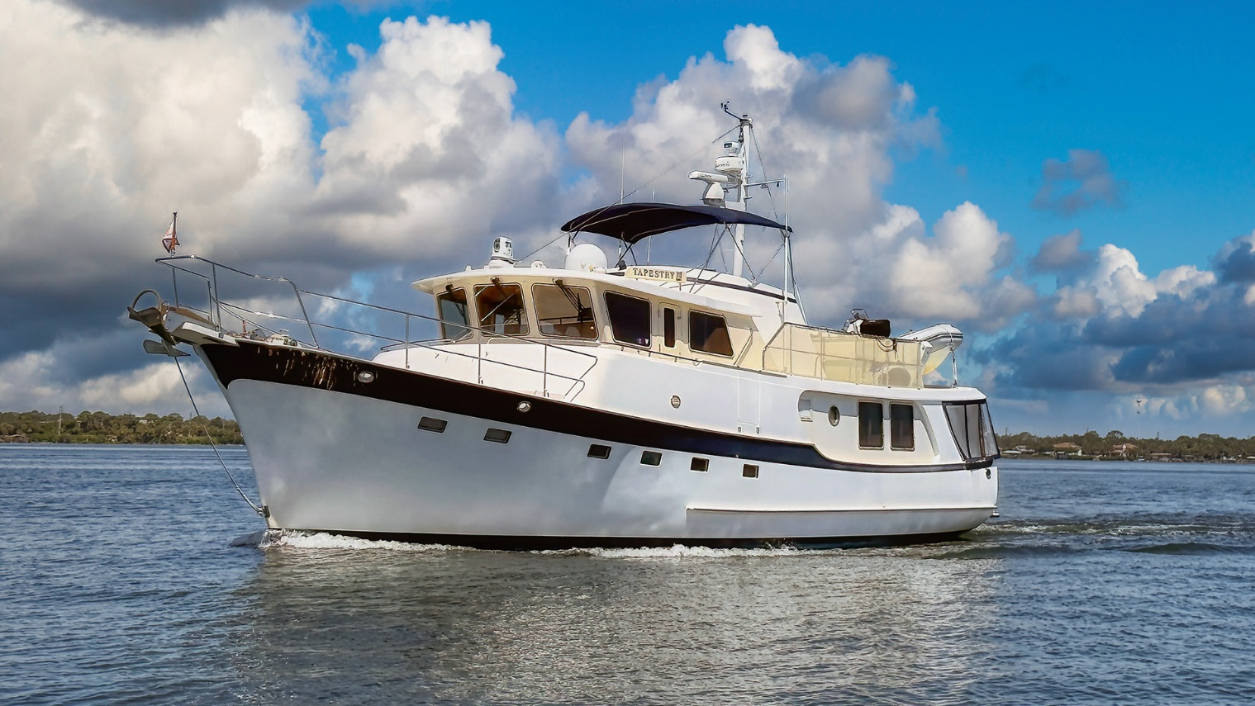
Tapestry

Price: $925,000.00 | Location: Indian Harbour Beach, FL
The Kadey Krogen 58 Pilothouse design is an exceptional long-range trawler designed and built to accommodate an active cruising couple. Tapestry is a magnificent rendition of the popular two-stateroom, two-head layout with an open office. Tapestry is offered for sale by her third owners after some light use over the past three years with mostly local cruising.
Tapestry is hull number 09 in the series and was delivered in 2005 and employs the preferred twin engine machinery configuration. She was also ordered with the widebody deck layout.
The entry level has the saloon merging into the galley. The interior is furnished with a very pleasing, light cherry wood finish. Carpet covers the parquet wood soles. The interior included Corian counter tops and Ultra-leather upholstery. The galley features a Viking propane cooktop; the pilothouse is a great collection of navigation and communication electronics. There are two sets of steps forward, one up to the pilothouse and the other down to the accommodations deck.
The office is to port on the lower deck across from the guest stateroom to starboard which has two single berths. From the hallway you can go aft to the engine room or forward to the owner stateroom. The guest head is across from the laundry and has an independent door from the hallway and a separate entry from the stateroom. The owner cabin forward features an island queen berth. This is a large, private stateroom with an ensuite head and shower. Interior comforts include five Cruisair® reverse cycle climate control units.
The pilothouse is impressive with a well thought out layout of displays and controls. There is a Stidd helm chair for operations and seating behind. Powered by twin John Deere 6068TFM50 main engines, the engine room also is fitted with 12kW and 20kW Northern Lights generators for electrical loads and ABT TRAC hydraulic active stabilizers for a smooth ride underway.
On deck, her aft cockpit has full enclosures and the widebody deck allows easy access from the cockpit forward along the starboard side. The Portuguese Bridge has storage lockers and a docking station to starboard. The foredeck features a Maxwell windlass. On the boat deck an AB model VST 13ft tender with a 60 HP Yamaha outboard are ready for launch via the Nautical Structures crane. The flybridge has two helm chairs for side-by-side enjoyment underneath a Bimini top and an L shaped settee with cushions and a table.
The ride through the water on a Kadey-Krogen 58 is smooth and efficient with ABT active fin stabilizers for comfort and a hydraulic bow thruster for docking convenience. Tapestry had numerous upgrades during the current and previous ownership. She is well outfitted, equally well cared for and ready for adventure!

For additional information please visit Tapestry’s website, KadeyKrogen58ForSale.com

YACHT NAME: | Tapestry
BRAND AND MODEL: | Kadey-Krogen 58
TYPE: | Long range passage maker with raised pilothouse and flybridge
LOCATION: | Indian Harbour Beach, FL
MODEL YEAR: | 2005
HULL NUMBER: | 9
HULL COLOR: | White gelcoat
DECK: | Teak wood cockpit and side deck - non-skid gelcoat, white deck with beige non-skid
REGISTRY: | United States Coast Guard documented
DESIGNER: | Jim Krogen
BUILDER: | Asia Harbor Yacht Builders Co., Ltd. - Taiwan
HULL MATERIAL: | Solid Fiberglass
DISPLACEMENT: | 96,830 lbs. | 43.92 MT
BALLAST: | 7,000 lbs. | 3,175.15 KG (Encapsulated lead)
RANGE: | 3,840 miles @ 7 knots
SPEED: | Cruise 9.0 knots. Top 12.0 knots (2,400 rpm)
LOA: | 63' 3" | 19.3 M (Includes bow pulpit and swim platform)
LWL: | 52' 3” | 15.93 M
BEAM: | 18' 10" | 5.74 M
DRAFT: | 5' 3" | 1.60 M
D/L: | 303
A/B: | 2.6:1
Cp: | Prismatic Coefficient .64
AIR DRAFT: | 28’ 0" | 8.53 M to top of mast (estimate) Note: mast has hinge base and can lower to approximately 17'0".
PORT ENGINE: | John Deere | 6068 TFM50 |158 BHP (Main hours: ~8,130) September 2025
PORT TRANSMISSION: | Twin Disc Model MG5075 4A | 2.88:1 reduction gear
STARBOARD ENGINE: | John Deere | 6068 TFM50 |158 BHP (Main hours: ~8,120) September 2025
STARBOARD TRANSMISSION: | Twin Disc Model MG507 A | 2.88:1 reduction gear
PROPELLER / SHAFT: | 2" Aquamet 22 shafts | Tides dripless shaft seals |Aquadrive anti-vibration systems | Four blade propellers 32"x 24" | Spurs line cutters
EXHAUST: | Wet exhaust, Centek Vernalift muffler
THRUSTER: | American Bow Thruster 10" tunnel, 25 HP hydraulic (3-Station)
STABILIZATION: | ABT TRAC Digital 250 hydraulic with 9 square foot fins
ELECTRICAL: | 60 Hertz – US style - 50 amp
SHORE POWER: | 50 amp connections: (2) stern cablemasters |(2) bow connections
GENERATOR 1: | Northern Lights 20 kW in sound shield with PTO (Hours ~ 3,970) September 2025
GENERATOR: | Northern Lights 12 kW in sound shield (Hours: ~3,910) September 2025
INVERTERS/CHARGERS: | Xantrex Trace SW4024 sine wave inverter/charger | Dolphin Charger | (3) Acme isolation transformers
BATTERIES: | (12) Twelve sealed AGM Lifeline GPL-4CT 6V for house 24/12V service (4) Four Group 31 sealed AGM 12V for engine starting (2) Two Group 27 sealed AGM 12V for generator starting (2) Two Group 31 sealed AGM 12 V for helm electronics
INTERIOR LIGHTING: | LED | Incandescent | Pilothouse chart lights
WATER MAKER: | Spectra 24V 400 GPD
CLIMATE CONTROL: | Five (5) Cruisair Marine HVAC Units
MACHINERY EQUIPMENT: | Reverso Oil changer
WINDLASS: | Maxwell HWVC-3500 double horizontal chain wheels, vertical warping capstan
GROUND TACKLE: | Rocna 70 Anchor | 500' 1/2 G4 chain | Secondary 45 lb. Scoop | 50' chain G4 with 300' rode
DAVIT/CRANE | Nautical Structures hydraulic crane lifts 1200 lbs.
TENDER AND OUTBOARD: | AB Model VST 13' RIB | 60 HP Yamaha outboard
NAV/COM BRAND: | Garmin | ICOM | KVH | Vesper AIS | Standard Horizon | Starlink | FLIR
ENTERTAINMENT: | Visio 40” flat screen TV in saloon | Bose sound system
STATEROOMS: | Two: Owner forward, (1) Guest amidships
BEDDING: | Custom mattress in owner stateroom
HEADS: | (2) Tecma electric freshwater
SHOWERS: | (3) Owner with seat and folding shower door | Guest with seat and folding shower door | Cockpit shower
LAUNDRY: | Bosch 800 series separate clothes washer and clothes dryer
GALLEY: | Viking Professional (4) burner propane stove and oven | JENN-AIR double door refrigerator/freezer | General Ecology Seagull IV whole boat fresh water purification system | GE Monogram trash compactor | GE microwave convection oven | Raritan ice maker | Bosch dishwasher
INTERIOR WOOD: | Cherry Wood - matte, semi-gloss finish
INTERIOR COUNTERS: | Corian counters
INTERIOR UPHOLSTERY: | Ultra Leather
INTERIOR FLOORING: | Parquet covered with wool carpet
BILGE PUMPS: | Electric standard and electric highwater
TANKAGE: (approx.)
FUEL: | 1,760 gallons | 6,662 L (Aluminum)
HOLDING BLACK: | 100 gallons | 379 L (Fiberglass)
FRESH WATER: | 400 gallons | 1,514 L (Stainless steel)
ADDITIONAL EQUIPMENT: | Stidd helm chair (Pilothouse), Kahlenberg M-511 Air Horn
SAFETY: | Fireboy fire suppression in engine room | EPIRB | USCG safety equipment |Winslow 6-person ultra-light offshore liferaft (expired)
PHOTO DATE: | Most detail photos were taken in July 2025
 | Note: All information is believed accurate but should be verified.

COCKPIT AND SWIM PLATFORM
The Krogen 58 has a back-porch feel in the aft deck/cockpit area. The swim deck area has U-rails and a swim ladder. The transom boarding gate swings aft to allow entry to the cockpit. The cockpit is a secure area with the boat deck offering protection above and Tapestry has an enclosure to make this a versatile outdoor room. The cockpit has a port side and starboard side hull doors for dock access.
- (3) removable stainless staple rails (sockets to reposition)
- Pop up cleats in swim platform
- Swim ladder: 4 step stainless steel telescoping under swim platform.
- Awlgrip painted caprails
- Double opening door to saloon
- Two teak chairs and a teak table with folding leaves
- Fiberglass console with freshwater sink and storage
- Shore power electrical connections with Glendinning retrievers
- Scanvik hot and cold freshwater shower.
- Fresh water hose bib
- EZ2See clear "glass" plastic window enclosures
- Textiline roll-down sunshades
- Full set of cockpit screens
- Hawsepipes and cleats
- Freeing ports
- Fishing rod holders
- Stereo speakers
- Ships bell
- Fire extinguisher
- Flooring in the cockpit is natural teak wood flooring on cockpit and starboard side deck
- Standpipe for crane support above
- Boat hooks with storage
- Wind block side door for starboard side deck
- Large, hinged access hatch to lazarette below

LAZARETTE
The lazarette is a large below-decks area providing access to the steering system and shore power connections.
Primary entry is through the cockpit hatch which, when open, is supported with gas spring struts. A short stainless-steel ladder with teak steps makes it easy to climb down. You can also enter the lazarette from the engine room through a hinged metal door. The cockpit hatch has a locking slide bolt to prevent access when you are away from the vessel. Additional shelves have been installed to help organize mechanical spares, supplies and extra gear.
- Hydraulic steering
- (2) Glendinning shore power cable retractors with storage tubs
- Oil storage containers
- Spare parts bins
- Deadbolt to lock hatch to secure vessel when away
- Painted aluminum door with dogs to connect lazarette and engine room

SALOON
The saloon entry into saloon is through the double aluminum doors. The widebody layout makes for a roomier entry. To port, there is a cabinet aft and cabinets outboard below the windows, leading to the banquet cabinetry across from the galley. The port side is “open” and awaits your choice of furniture – a sofa, or chairs? The starboard side features an L-shaped settee covered in Ultra-leather that fits around the large hi-lo dining table. There are large windows outboard and aft, some are opening to allow for air flow. Built in cabinetry aft along the port side below the windows and forward across from the galley provides excellent storage. There is a flat screen television mounted above the starboard sofa. The saloon merges forward into the galley on the starboard side.
- Cherry wood interior
- Most lockers have louvered doors
- Air conditioning climate control throughout interior
- Parquet wood soles covered with decorative carpet
- Removable hatches in sole below carpeting for engine room service
- Double opening entry door aft with window panels and roller screen
- Opening windows outboard to port and starboard
- Windows have decorative valances, screens, blinds, and side window treatments
- Large settee upholstered seating area to starboard
- 40” Visio television in saloon connected to Bose surround sound system
Bose stereo and Bose speakers in pilothouse, saloon and cockpit.
- Hi-lo dining table with folding leaves
- Banquet area forward to port with counter space, lockers and drawers
- Round opening portlight
- Large pantry storage locker – louvered door with shelves
- Overhead safety grab rail
- Concealed double sliding cabinet in galley wall with lower double cabinets

GALLEY
The galley aboard Tapestry is set up to help feed a hungry crew. There are top-end home appliances as well as large counter surfaces for meal preparation. The layout makes it easy for two people to work side by side. There are many lockers and drawers for cooking utensils including pots, pans, dishes, bowls, glasses, etc. To port there is a cabinet with lockers, shelves and drawers know as the “buffet” including a built-in icemaker. Food provisions can also be stored in the large pantry locker directly across from the galley. Outboard is a Dutch door that opens to the starboard side deck, protected by a clever magnetic lined bug screen.
- Corian counters
- Viking Professional four burner gas range with gas oven,
- GE Profile microwave convection oven
- JENN-AIR full-size double door refrigerator freezer
- Bosch Silence Plus automatic dish washer
- GE Monogram trash compactor
- Double basin stainless steel sink
- Many under-counter drawers
- Multiple louvered door lockers
- Overhead storage lockers
- Drawers and lockers for cookware, appliances and utensils
- Dutch door to allow ventilation and access to the side deck (includes a full magnetic screen).

Moving forward from the galley you can go up to the pilothouse or down to living quarters comprised of an office, two staterooms and two heads with separate showers.

LOWER LEVEL - OFFICE to PORT
Heading forward from the entry level you descend a short set of steps to the accommodations deck. Welcome to the large open office area that takes over the port side. The lower-level landing area merges across to the guest stateroom to starboard and the forward hallway leads to the owner stateroom. The office area has impressive counter space and a working desk. There are shelves and portlights outboard. Aft is wine refrigerator, a chart locker, and custom hidden cabinet for storage (once used for a sewing machine).
- Desktop surface with keyboard tray
- Office chair on rollers
- Counter surface area
- Custom cabinet (no sewing machine included)
- Wine storage appliance
- Parquet floor
- Carpet
- Bookshelves
- Lockers and drawers
- (2) opening port lights with screens

Floor hatch provides access to the mid-machinery area just forward of the engine room step down access.

GUEST STATEROOM to STARBOARD
The first door to starboard opens up into the guest stateroom. There are two individual single guest beds with fitted covers and a nightstand between. There is a large hanging locker and multiple drawers. Outboard are opening port lights. Forward, and connected, is the guest head (which can also be accessed from the hallway).
- (2) single berths
- Drawers for clothing under bunks
- Nightstand
- Large hanging locker with louvered door
- Opening portlights outboard
- Built in lockers outboard with louvered doors
- Parquet floor
- Carpeting

GUEST HEAD
The guest head can be entered from the central hallway or from a private door forward in the guest stateroom. The shower is outboard and inside is a seat and opening portlight, closed off with a bi-fold door. There is a mirrored medicine cabinet above the sink cabinetry. The toilet is between the shower and the sink.
- Tecma fresh water flush electric toilet
- Corian counter
- Parquet wood sole
- Stand up shower with seat and bi-fold door
- Large linen locker

The lower-level hallway is floored with parquet wood and has two hinged hatches that cover over access to machinery spaces. The forward area just before the owner stateroom has a dedicated laundry area for the Bosch 800 series clothing washer and dryer.

OWNER STATEROOM
The large area below the foredeck is reserved for the owner stateroom. This optimum location is roomy and features a custom queen-size bed with memory foam mattress. Below the bed is a huge storage area, easy to reach due to hydraulic lifting rams. Ventilation is optimized with two overhead hatches and opening portlights. There are lockers and drawers for clothing and belongings. This is a private, quiet and comfortable stateroom.
- Large island berth with memory foam mattress
- Reading lights and bed stand counters
- Cushioned changing seats on each side of bed
- (6) drawers under the bed
- Storage lockers with louvered doors
- Hanging locker to port
- Hanging locker to starboard
- (10) drawer bureau with wall mirror
- (4) opening portlights with screens (two outboard on each side)
- (2) overhead hatches with screens
- Parquet wood flooring
- Carpeting

OWNER HEAD
The owner stateroom has a private door access to the head, sink and shower.
- Tecma electric flush freshwater toilet
- Standing shower with bench and bi-fold doors
- Vanity
- Louvered lockers
- Dual mirrored cabinets
- Opening portlight in shower
- Linen locker

Floor hatch access to below sole sanitary bilge area
- Fiberglass black water tank
- Electric black water pump
- Sanitation hoses and diverter valves.
- watertight hatch forward to access hoses and connections for windlass and bow thruster

PILOTHOUSE
A couple of steps up from the entry level leads to the pilothouse. The inboard cabinetry includes the primary electrical panel and displays for the generators and inverter. Underway operations are initiated in the pilothouse and can also be managed from the flybridge. The helm dash is precisely laid out for optimum operational functionality. Electronics include navigation and communication with VHF radios, radar, sonar, GPS, AIS and CCTV with views of the engine room, saloon and stern. There is a Stidd helm chair that provides a great view and easy reach to the primary controls. There is a wraparound upholstered L-shaped raised settee with table behind the helm chair. There are vented cabinets with drawers and double chart drawers on each side of the helm station. There are sliding windows to port and starboard and two rear portlights, all with screens. Dutch doors with (phantom screens) provide outside deck access
- Stidd helm chair
- Stainless destroyer wheel.
- ZF dual lever controls for both Deere engines
- Hydraulic bow thruster
- Windlass controller
- Active fin stabilizer control pad
- Kahlenberg horn
- Floscan engine monitor and fuel use rate system for each main engine
- The L-shaped watch settee with Ultra-leather that also converts to a double berth with storage available directly under the settee.
- Aluminum Dutch doors with Phantom screens
- Handrails

Navigation and Communications:
- Garmin GPSMAP 7616xsv 16" multi-touch chart plotter/sonar combo (2 units)
- Garmin GPSMAP 7612 12" multi-touch chart plotter (Flybridge)
- Garmin GMR 424 xHD2 open array radar and pedestal (72 N mile)
- Garmin GPS/GNSS, 10Hz, 32 channel receiver.
- Garmin GMR Fantom 18x broadband Doppler radar (48 N mile)
- Vesper XB-8000 AIS transponder with built-in Wi-Fi, NMEA 2000 Gateway and high speed 5Hz GPS receiver
- Garmin GHP20 Reactor autopilot with smart-pump system and fast heading sensor
- (2) additional Garmin GHP20 Autopilot controllers (flybridge & wing stations). Garmin GRF10 rudder feedback sensor
- Garmin GC10 and KJM waterproof cameras (4 total) with IRIS606 interface to Garmin chart plotters, controllers in pilothouse and flybridge.

NMEA2000 network:
- Airmar B60 thru-hull depth/fish finder transducer connected to NEMA network.

FOREDECK
Forward of the pilothouse windows is the Portuguese Bridge with center access to the foredeck and built-in storage lockers and seating. The foredeck’s primary function is to support the ground tackle arrangement for safe anchoring. This is supported through the Maxwell 3500 double chainwheel hydraulic windlass with capstan. The bow pulpit secures two separate anchors on individual rollers with the primary being a self-launching Rocna 70 (154 lb.). There is a Freeman hatch to port for entry to the chain locker. There are shore power connections plus fresh and a seawater washdown. The deck is uncluttered with two opening hatches above the owner stateroom.
- Maxwell 3500 double chainwheel hydraulic windlass with capstan
- Chain stoppers
- Rocna 70 (154 lb.) primary anchor
- Mantus chain claw on line connected to bow eye to reduce scope for anchoring
- Shore power connections
- Deck wash connections
- Freeman hatch access to chain locker
- Cleats and hawsepipes
- Bow pulpit with burgee socket

BOAT DECK
This section is really in two parts. Aft, behind a stainless steel “fence”, the tender is mounted to be offloaded by the crane. The forward section has plenty of space and up forward the hinged antenna mast stands with access lockers built into the raised deck platform of the flybridge.
- AB model VST 13ft inflatable tender (2016, starting to show age)
- Chocks and tie downs
- 60 HP Yamaha outboard
- Nautical Structures Euro 1200 (1,200 pound lifts) crane
- Textilene weather cloth privacy/safety screening on all rails
- Magma Newport II gas grill with own propane tank
- Propane storage locker (for galley appliances below deck)

FLYBRIDGE
The upper helm station is above the pilothouse and protected under the Bimini top. This is an enjoyable location to run Tapestry and to also soak in your surroundings when you are at rest. Great sight lines all around and easy visuals for navigation displays as well as easy reach to other controls including windlass, search light, air horn, VHF radio, etc.
- Folding Bimini over flybridge helm
- (2) helm chairs
- Stainless steel helm
- Engine displays and controls
- Danforth compass
- Kahlenberg horn control pad
- Garmin chart plotter/radar display
- L shaped settee to port with a table
- Mast with spreaders, lights and antennas (including both radars)
- Mast is on a tabernacle hinge base that can be lowered for bridge clearance - resting on a built in cradle in boat deck railing
- Winch for easy mast lowering/raising.

ENGINE ROOM
One of the best features of the Kadey-Krogen 58 is the access and layout in the engine room. The primary entrance is from the lower deck hallway, down a couple of steps. Once you enter this well-lit area, there is a work bench to starboard with a tool chest atop. This forward alcove also provides for quick inspection of the fuel manifolds and Racor fuel filters. There is a centerline walkway between the two John Deere main engines (floorboards over the bilge). The ABT TRAC stabilizers are forward and outboard, the two Northern Lights generators are aft. The layout allows for easy inspections and serviceability. There is a door all the way aft that connects to the lazarette.

MACHINERY DETAILS
Engines: (2) John Deere 6068TFM50 158 BHP@2400 rpm
Twin Disc 2.88:1 gear ratio transmission’s
Engine mounts: Aqua Drive antivibration system
Shafts: (2) Aquamet 22 stainless steel, 2" diameter with dripless shaft seals
Propellers: (2) bronze, 4-blade, 32" diameter x 24" pitch
Engine controls: ZF Mathers MicroCommander, electronic (3-station)
Fuel filters: Dual Racor with vacuum gauge for each engine and each genset
Machinery climate: Engine room temperature monitor and cooling fan controller
Fuel Polishing/transfer system with manifold for all (4) fuel tanks.
Lube oil transfer system: Reverso 24V with manifold for changing oil on engines, transmissions, and generators
Generators: Northern Lights with sound shield, 20kW with PTO and 12 kW
Bow thruster: American Bow Thruster 25 HP hydraulic (3-station).
Active fin stabilizers: American Bow Thruster TRAC system, 9 sq. ft. fins.
Fireboy automatic fire suppression system
Windlass: Maxwell 3500 double chainwheel hydraulic with capstan
Crane: Nautical Structures Euro 1200 (1,200 pounds)
Rudders: stainless steel, oil filled, with protective skeg shoes
Steering: Hydraulic
Bilge Pumps: (5) 2,000 GPH with high water alarms at helm station
Water Maker: Spectra 24V 400 GPD
Torrid Marine 30-gal stainless steel water heater

ELECTRICAL
Generator 1: Northern Lights 20kW with PTO
Generator 2: Northern Lights 12kW
Shore power: 50A connections (2) stern Glendinning Cablemaster | (2) bow connections for shore cords
AC power isolation transformers: (3) Acme with step-up voltage switching
Water heater: Torrid Marine 30-gallon stainless steel
Galvanic isolators: Two (2) Newmar GI-50 isolators
Inverter/charger: Xantrex Trace SW4024 sine wave
DC Monitors: Link 10 battery monitor plus digital volt/amp displays in breaker panels
Batteries: (12) sealed AGM Lifeline GPL-4CT 6V for house 24/12V | (4) Group 31 sealed AGM 12V for engine starting | (2) Group 27 sealed AGM 12V for generator starting | (2) Group 31 sealed AGM 12 V for helm electronics

Over $120,000.00 was spent by the current owners doing service work since the start of ownership in 2023.

The detail photos of Tapestry were taken in July 2025. Please get in touch to schedule your personal appointment to walk aboard this beautiful vessel and discuss her in greater detail. We believe you will then fully appreciate the value that Tapestry represents.
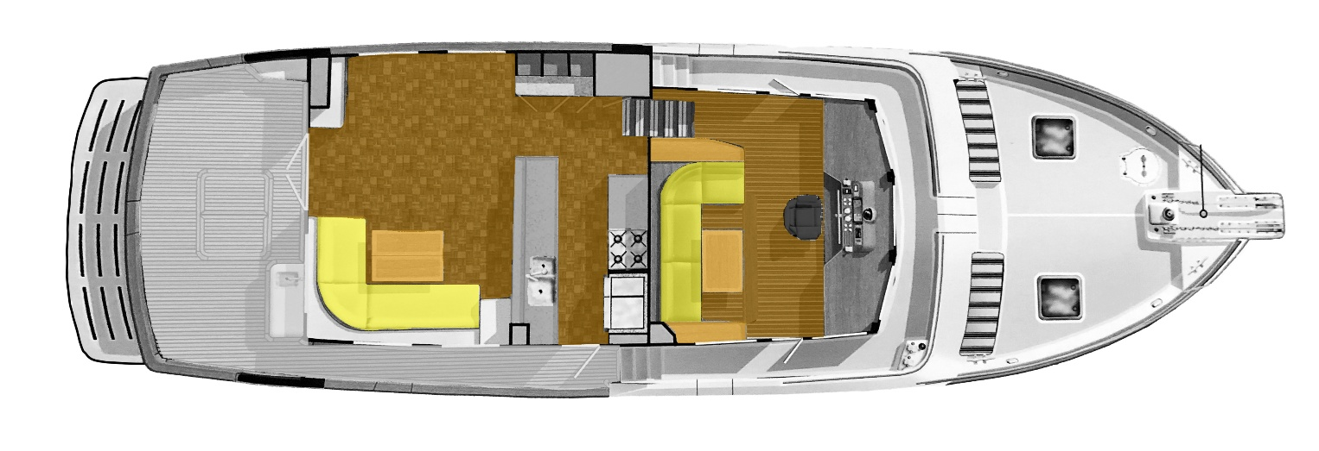
LAYOUT: Main Level - Saloon, Galley, up to Pilothouse

LAYOUT: Lower Level – Engine room, Office, Staterooms and Heads
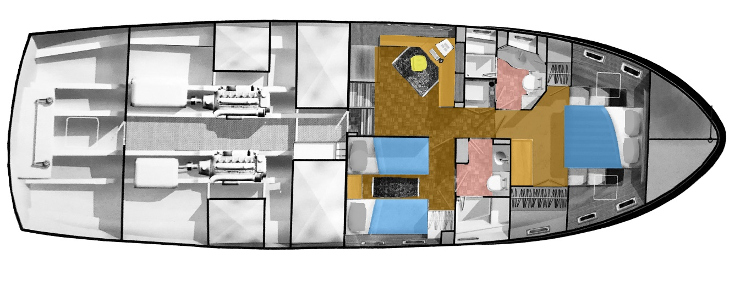

Kadey Krogen 58 Tapestry Talk Through Tour

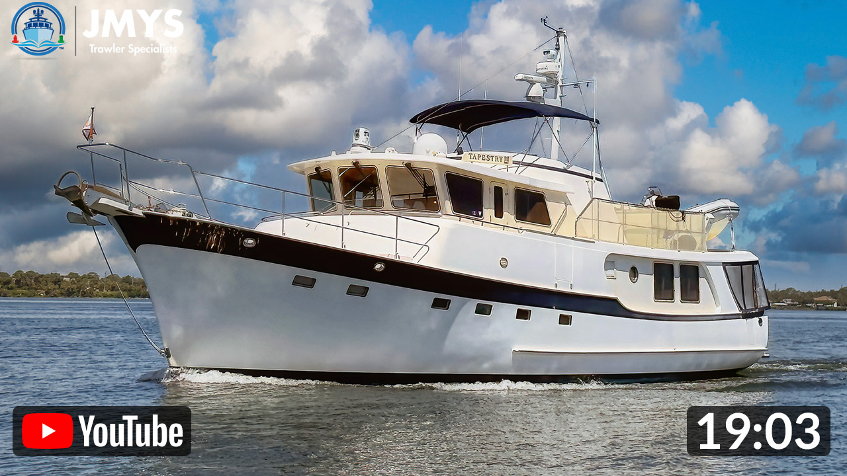
https://www.youtube.com/watch?v=lhqHeWvySW8&t=33s
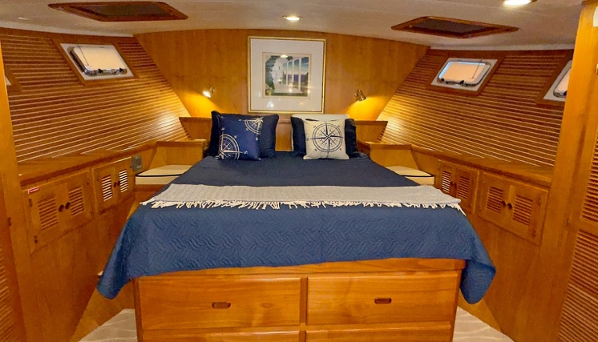
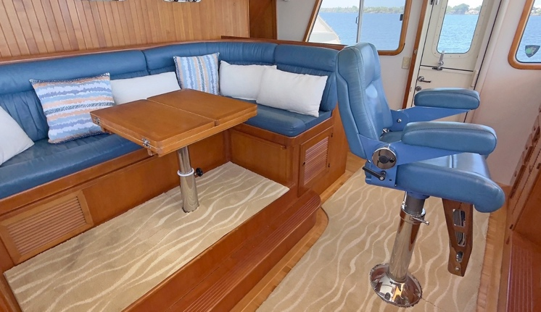
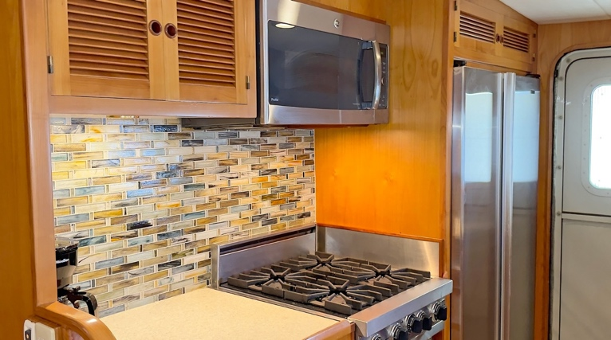
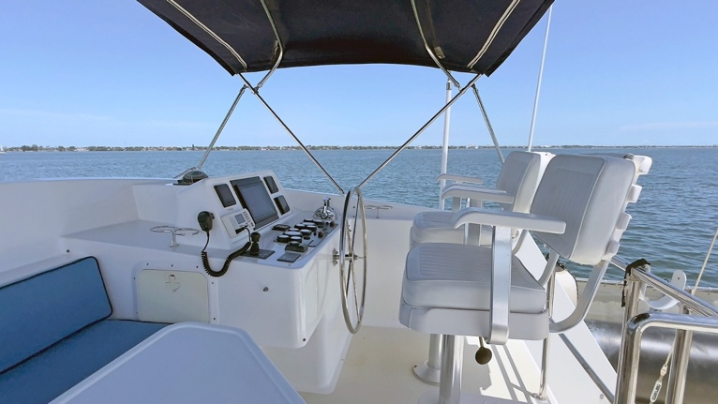

Exclusions: Potential purchasers should assume that items on the vessel at the time of viewing, but not specifically listed on this sheet, are not included with the sale of the yacht. These specifications are believed to be true and correct but cannot be guaranteed. Items excluded include, but are not limited to Paintings, tools, handheld nav gear and binoculars. The owner’s personal effects and clothing will be removed prior to closing.
Disclaimer: Jeff Merrill Yacht Sales, Inc. presents the details of this vessel in good faith but cannot guarantee or warrant the accuracy of this information nor guarantee or warrant the condition of the vessel. Buyers should instruct their agents and their surveyors to investigate all details the buyers desire validated. This vessel is offered subject to prior sale, price change, or withdrawal without notice.
Brokerage: JMYS is a US based (licensed and bonded yacht brokerage in California, Florida, Virgina and Washington) with an international emphasis specializing in ocean capable trawlers and recreational tugs. Our brokers are experienced boaters; most are trawler owner/operators with thousands of hours and miles at sea. The team at JMYS has extensive trawler and motor yacht product knowledge and our skills are available for coaching after the sale has concluded.

Co-Brokerage: Fellow yacht broker association members: Lightning is available for Co-Brokerage, please call to discuss special listing arrangements in place. This listing specification has been approved by the sellers for accuracy. The photos, images and descriptive content are copyrighted by JMYS and may not be copied or used without specific written permission.

*Listing broker. John Hoffman



Listing broker: John Hoffman has years of experience working with the Nordhavn brand over the years, having retired from his position as Nordhavn Commissioning Manager in 2015. John’s product knowledge, systems skills and friendly, helpful attitude have helped him excel as a JMYS yacht broker. John has his yacht salesman license in Florida. Please contact listing broker John Hoffman for additional information or to schedule a viewing appointment. You can email John at John@JMYS.com or call/text +1 772.215.3720.
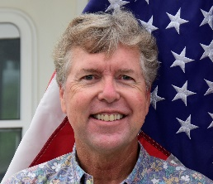
Listing broker. Jeff Merrill, CPYB (Certified Professional Yacht Broker) has extensive product knowledge of the trawler market plus direct experience with the Kadey-Krogen brand and is very well acquainted with the 58 model and Tapestry, specifically. Jeff is a familiar face to YouTube viewers and a regular presenter at TrawlerFest. He has written dozens of articles about trawlers for Ocean Navigator and PassageMaker magazines and is one of the online instructors for Boaters University.
Please contact listing broker, Jeff Merrill, CPYB by phone, text or email for additional information or to schedule your personal showing. Jeff is available via Mobile + 1 949.355.4950 (Call, WhatsApp or Text). You can send a detailed Email to: Jeff@JMYS.com.
Licensed and Bonded in California, Florida, Virginia and Washington. Mobile call/text/WhatsApp +1 949.355.4950 | Email: Jeff@JMYS.com You Tube: Jeff Merrill Yachts| Twitter: @merrillyachts | LinkedIn: jeff.merrill
Facebook: Jeff Merrill Yacht Sales | Instagram: JMYSTrawlers Chairman, Certification Advisory Council (CAC) for CPYB 2023, 2024 and 2025 Yacht Brokers Association of America | International Yacht Brokers Association (Florida) | Northwest Yacht Brokers Association | California Yacht Brokers Association – President 2015 and 2016


